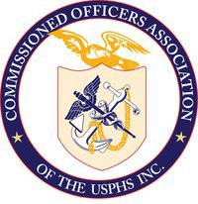District of Columbia

Commissioned Officers Association (DC COA)

United States Public Health Service

# District of Columbia Commissioned Officers Association

**LCDR Michael (Geng) Tian, PhD**

# Secretary

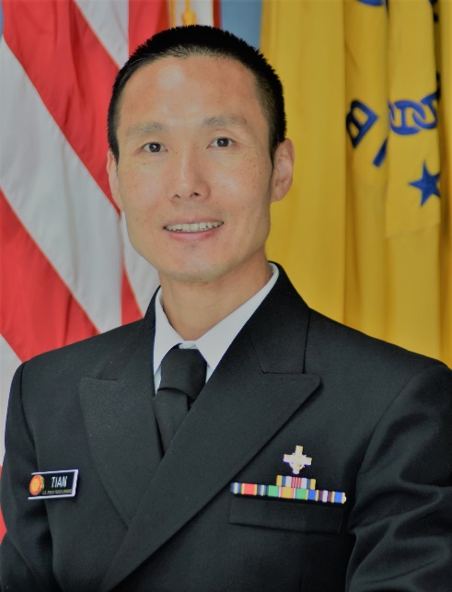

Lieutenant Commander Geng (Michael) Tian, Ph.D., serves as a Lab Chief in the Office of Pharmaceutical Quality Research, Office of Pharmaceutical Quality, Center for Drug Evaluation and Research, Food and Drug Administration (FDA). He leads various FDA intramural research projects aimed at facilitating regulatory quality assessment of drug applications utilizing emerging manufacturing technologies. Michael also acts as a technical liaison, collaborating with industry stakeholders, academic institutions, and government agencies on numerous FDA extramural research projects to advance the development and implementation of emerging manufacturing technologies ensuring drug quality. He contributes actively to guidance development, addresses regulatory consults, and participates in workgroups, presentations, and publications. In February 2024, Michael was honored with the prestigious accolade of 2024 Federal Engineer of the Year for the FDA by the National Society of Professional Engineers.